North Carolina Department of Transportation and North Carolina Wildlife Resource Commission
Wildlife Crossing Guidance

Background
In 2023 the North Carolina Department of Transportation (NCDOT) and the North Carolina Wildlife Resources Commission (WRC) entered into a Memorandum of Understanding (MOU). This NCWRC/NCDOT Wildlife Stewardship MOU is intended to foster and enhance stewardship through communication and cooperative projects between the two agencies including, but not limited to, the following categories: cooperative project planning and coordination; public safety; maintenance and expansion of habitat connectivity and wildlife habitat conservation; inventory, monitoring, and biological studies; impacts to wildlife due to vehicles; habitat loss due to invasive species; maintenance of recreational access; information and education; and conflict resolution.
This guidance document is a tool identified for development under the MOU to facilitate communication and stewardship related to wildlife passage. It is a living document, and updates will be made as new information, techniques, and technologies are developed. Guidance is based on observational information as well as peer reviewed reports and literature, as cited. For further information, you may contact epu@ncdot.gov or travis.wilson@ncwildlife.org.

Introduction
Wildlife crossing structures and fencing reduce habitat fragmentation and facilitate wildlife movement under or over North Carolina’s roads and highways. NCWRC monitoring has shown that properly planned and implemented dedicated wildlife crossings are effective in North Carolina. Because of cost these structures typically involve priority wildlife habitats, species conservation needs, and/or identified safety concerns. However, simple extensions or additions of dry passage and other low-cost design modifications to bridge and culvert replacement projects can also provide opportunistic wildlife habitat connectivity at minimal cost and on a much broader scale.

Bridges and Culverts
Many of North Carolina’s bridges and culverts already accommodate wildlife movements. Extending dry, clear passage areas under a bridge or improving a culvert crossing during maintenance is the most cost-effective and practical method to connect North Carolina’s wildlife habitats statewide. Wildlife fencing can dramatically improve the efficacy of wildlife crossing structures (information about fencing considerations is included in the next section). Standard low or no cost considerations have been developed and are described here for routine maintenance and roadway construction designs to enhance wildlife passage past North Carolina highways.
Increasing hydraulic capacity results in larger structures that provide better habitat connectivity. Bridges typically provide more span width and open area than culverts and thereby often better accommodate wildlife movements for a broader range of species. In-kind bridge-to-bridge replacements, or culvert-to- bridge replacements, should be pursued in areas with higher wildlife usage such as along high-quality streams, streams in rural areas, streams with long forested riparian areas or adjoining wetlands, and intact riparian corridors. Bridge span should be increased if sloping abutments preclude the ability to provide clear floodplain or streambank area under the structure. For single pipe or box culvert crossings, widths that allow bedload retention and floodplain/streambank construction should be pursued while also maintaining a natural stream channel width, which may require notched sills or baffles per NCDOT hydraulic guidance (Figures 1 and 2). Where practical, high flow floodplain barrel/s should be added to crossings for dry passage area, the necessary hydraulic design capacity, and maintenance of baseflow channel dimensions for aquatic passage (Figures 3 and 4).

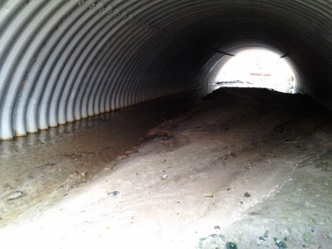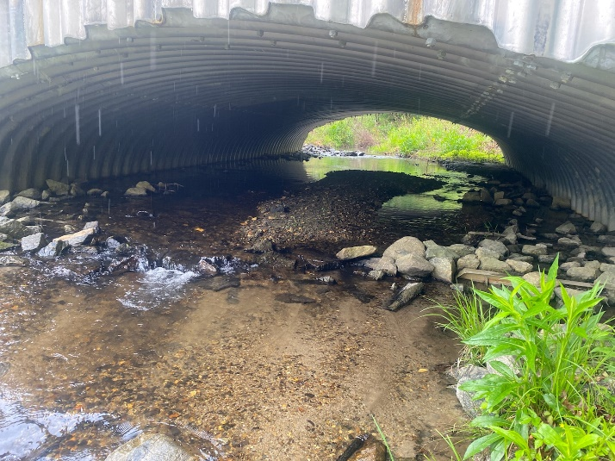
Figures 1 and 2. Wide corrugated metal pipe (Wayne County, SR 1300, Unnamed Tributary) retaining bedload (left) and aluminum box culvert (Transylvania County, , #870163, North Prong Glade Creek) with notched sills and baffles buried by bedload (right, note partially exposed sill in photo right).

Benching
Floodplain or approach benches must be constructed to transition high flow culvert barrels or dry benching in or under single pipes, boxes, or bridges, into the stream banks upstream and downstream of the structure (Figure 3). This will encourage wildlife use by creating a continuous and unobstructed connection of habitats on either side of the roadway. Bank sloping may be required on incised stream channels to transition the floodplain or lower dry ground elevation down to the bench elevations (Figure 4).

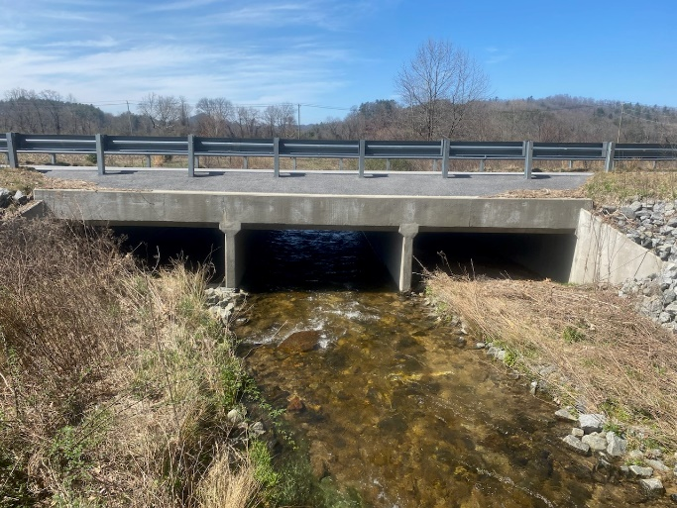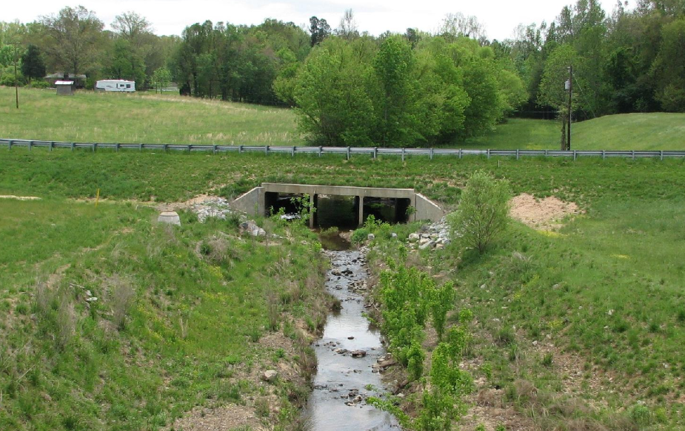
Figures 3 and 4. Benching into box culvert (left, Transylvania County, #870012, Hogsed Creek) and benching with bank sloping (right, Mecklenburg, associated with I-485, unk. stream).

Rip Rap / Armoring
Full armoring of streambanks or sloping abutments can deter passage of wildlife that move along stream corridors and encourage at grade road crossings attempts. Widespread use of rip-rap creates barriers or impediments to wildlife movement. Rip-rap should be avoided where effective erosion control and stabilization can be achieved without armoring. Where armoring must be used, the following guidance will reduce habitat fragmentation.
- Rip rap must be avoided under new bridges where not needed for scour protection or slope stabilization (Figures 5-7). Where plating is used, a rip rap free area should be incorporated in the excavated slopes, or a path constructed over the rip rap using aggregate, coarse stone, or floodplain material that fills-in voids and creates a flat surface (Figures 8 and 9). Where possible rip rap should be keyed-in or embedded below grade before overfilling with native material or aggregate, as approved (Figures 10 and 11).

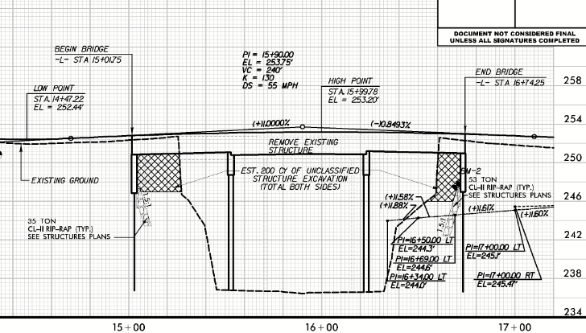
Figure 5. Unarmored slopes on proposed Anson bridge #030217 over Lanes Creek.
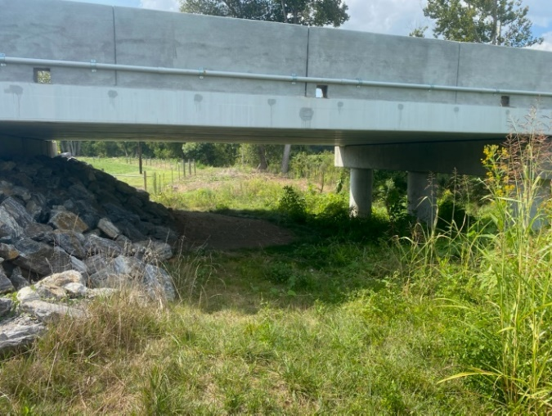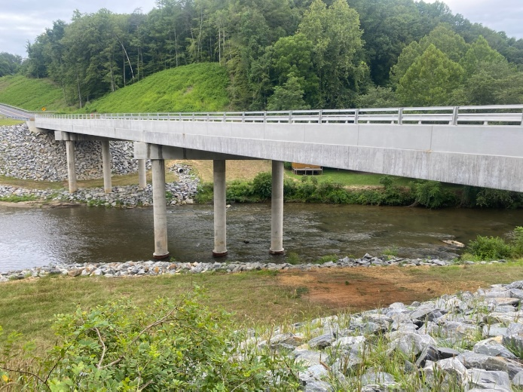
Figures 6 and 7. Unarmored floodplains under bridge in Iredell County (left, #480212, Patterson Creek) and large bridge in Stokes County (right, #840008, Dan River)
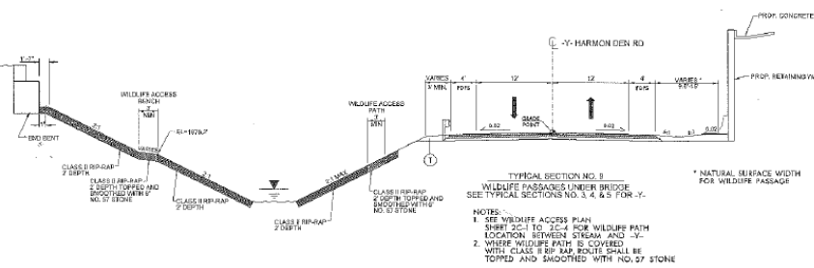
Figure 8. Wildlife pathway detail over rip rap (B-6054A, Haywood #430057).
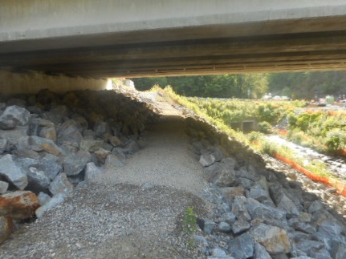
Figure 9. Wildlife pathway or ”bench” as-built from Figure 8.
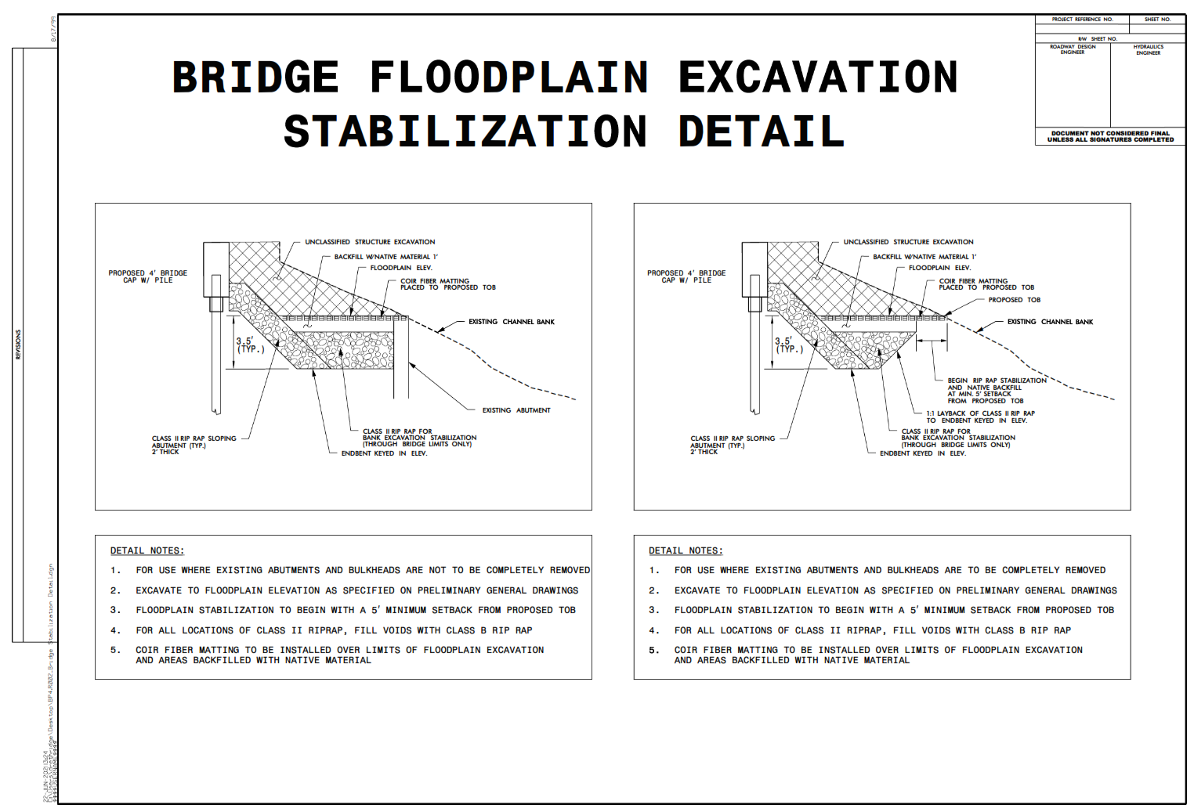Figure 10. Rip rap embedment detail for benching.
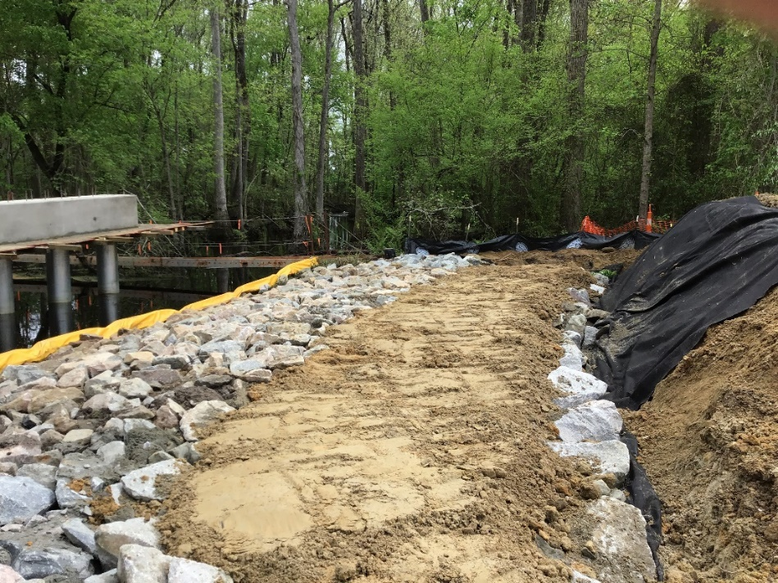
Figure 11. Construction of bench over embedded rip rap (Edgecombe County, # 320113, Otter Creek).

- Rip rap used for floodplain benching and as back-fill inside culvert barrels must be topped with native streambed/floodplain material to reduce roughness and rip rap voids that can deter wildlife use. (Figures 3 and 12). The construction engineer or environmental staff should approve all material used.

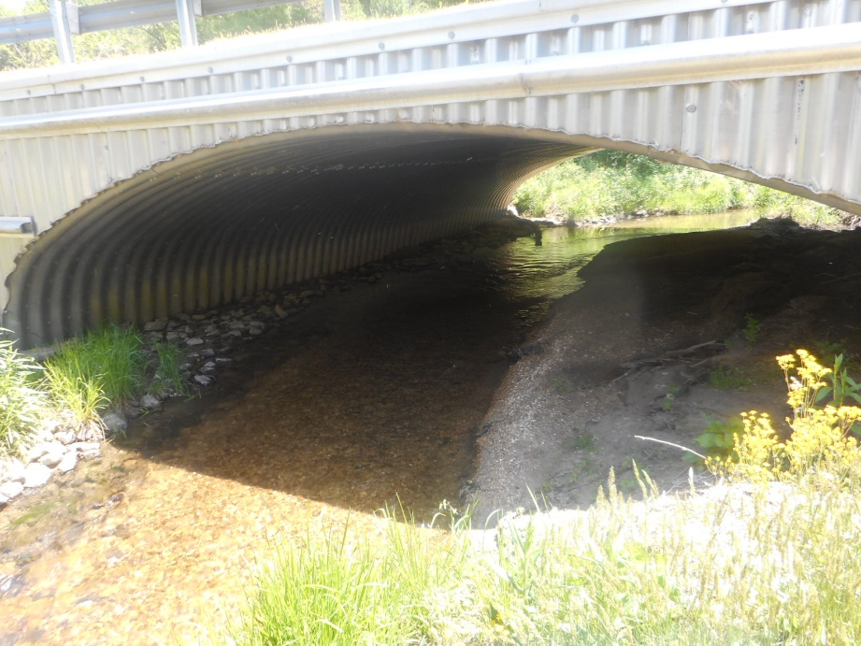
Figure 12. Native material over rip rap backfill in aluminum box culvert (Henderson County, #440073, Greer Creek).

- Like the topping of wildlife pathways and floodplain benches, rip rap used in drainage channels/ditches between road shoulders and adjoining habitats should include a section of aggregate material over the rip rap which ties into the culvert or bridge benching. This will provide a continuous, unobstructed connection from habitats to passage areas under or within the structure.

Dedicated Structure Design
Projects specifically identified for conservation needs or vehicle collision reduction will be planned and developed in accordance with the 2023 Wildlife Stewardship MOU under established procedures (e.g., NEPA/SEPA scoping, NEPA/404 merger,…). Such projects typically involve new roadways or upgrades to existing facilities where traffic capacity will be increased (e.g. major widening), there are legacy conservation needs, and/or wildlife vehicle collision issues have increased or developed over time. Available wildlife population and habitat information, roadkill rates, cost estimates and benefit analyses, and other pertinent supporting information will be collectively considered where these dedicated wildlife passage accommodations are pursued for either safety or conservation.
The NCDOT is challenged to responsibly manage public funds while addressing an increasing number and complexity of regulatory and planning considerations to deliver transportation projects. The NCWRC is similarly charged with ensuring public funds are used for conservation priorities and objectives. Cost-benefit analysis of safety/habitat connectivity measures must validate the extra costs associated with providing habitat connectivity/safety measures.

Structure Types and Objectives
There are several dedicated wildlife crossing structures in North Carolina with different designs and objectives. Large crossing structures can be wildlife overpasses that allow wildlife to travel over the roadway or underpasses in the form of bridges (Figures 13 and 14). North Carolina has several successful wildlife underpasses that are preferred options in situations such as flat terrain. Large crossing structures are typically used to target large mammal species. By contrast, site specific or species-specific crossings will typically cover a much smaller area and may only utilize small crossing structures (Figure 15). Structures intended to provide ecological connectivity should provide both the ability to pass large mammals as well as small mammals, reptiles and amphibians. Connectivity projects will often include multiple structures providing better habitat connectivity and conservation value particularly for small and/or range limited species.

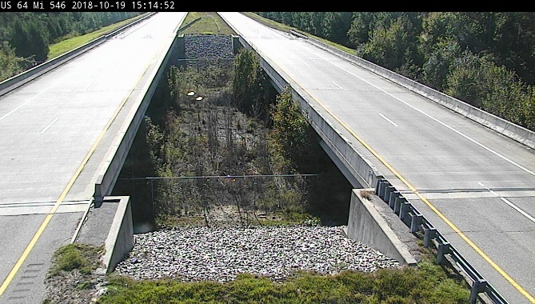
Figure 13. Wildlife underpass on US 64 in Washington County.
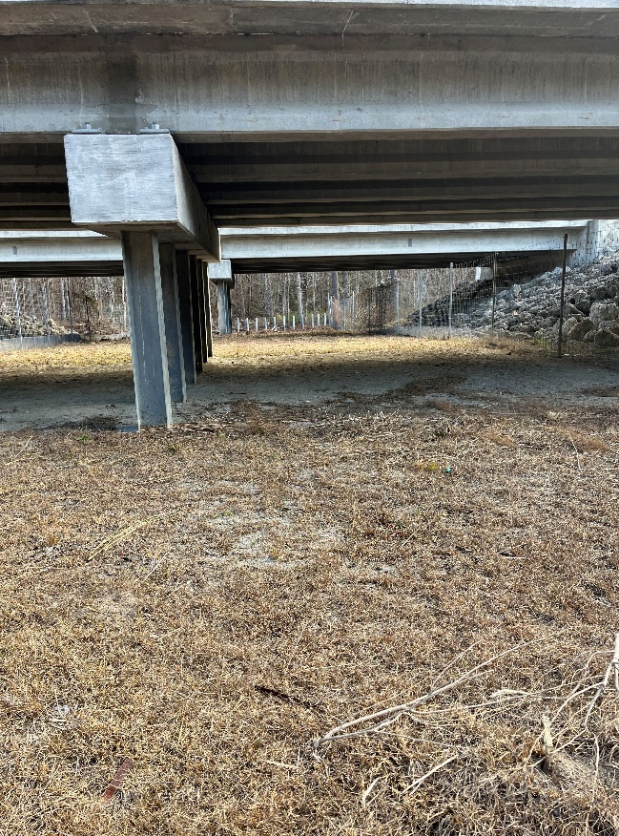
Figure 14. Wildlife underpass on US 17 in Jones County for connecting habitat for range of species.

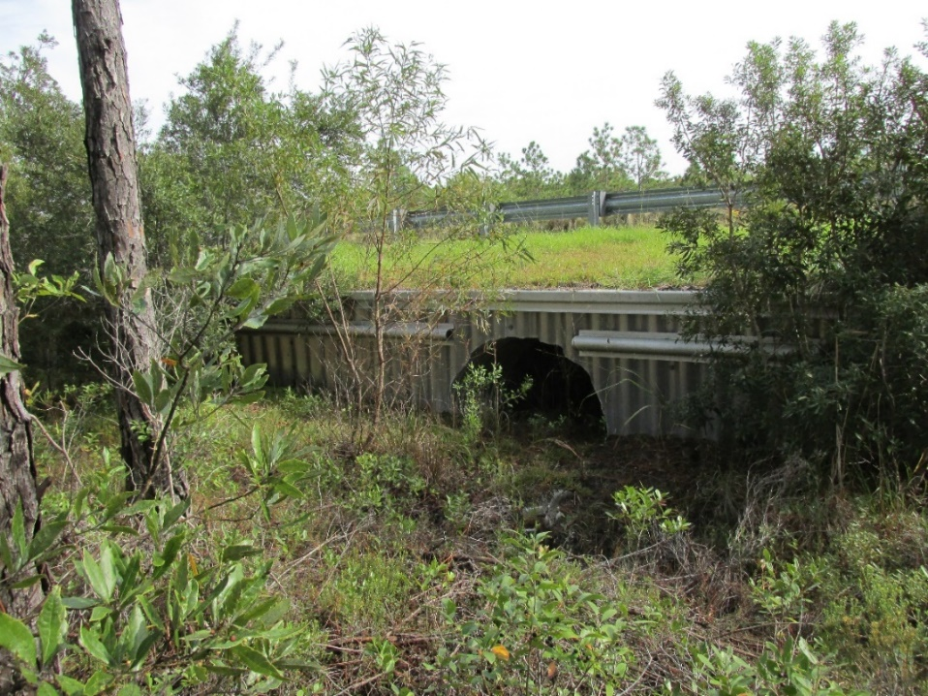
Figure 15. Culvert designed for small and medium animal passage on EF Middleton Blvd. Brunswick County.

Culverts offer a wide range of designs and sizes to provide passage for medium and small species with some larger species commonly using them as well (Figure 15 and 16). When incorporating culverts for wildlife passage the following key design features are important and should be evaluated: 1) culverts should be aligned to provide a clear line of sight through the structure (Figure 17), 2) culverts should be backfilled to provide a natural substate, 3) grates in the culvert are beneficial to allow light and acclimatization to outside conditions (Figure 18), and 4) any grates need to be elevated and approaches to culverts need to be graded to prevent concentrated storm water from entering the crossing structure. In some cases, specialized crossing structures such as full open grate structures may be necessary to effectively provide wildlife passage (Figure 19).
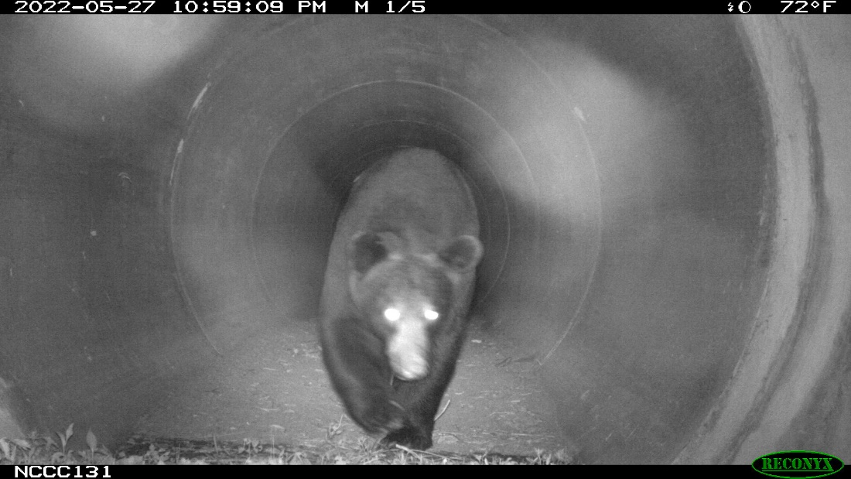
Figure 16. Bear in culvert, US 17 Wildlife Crossing Jones County
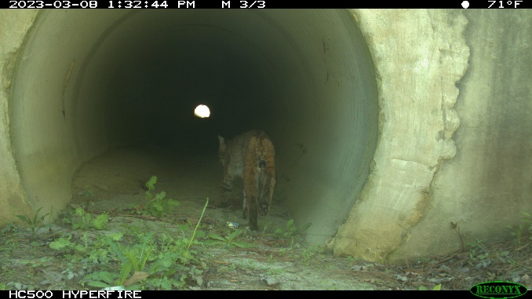
Figure 17. Daylight visible through culvert, US 17 Wildlife Crossing Jones County.
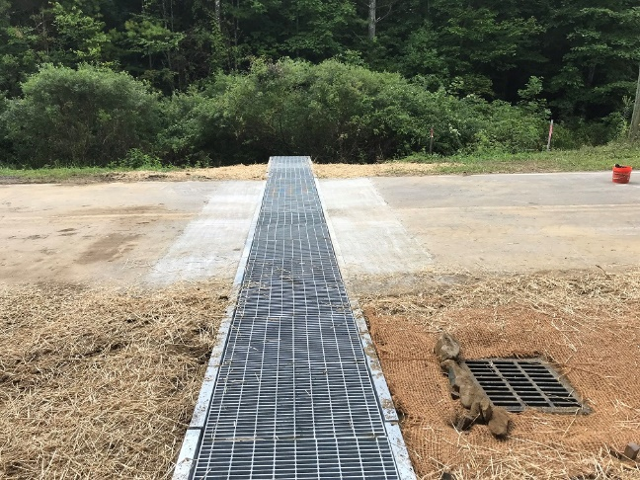
Figures 18 and 19. Grate in median of wildlife culvert, EF Middleton Blvd Brunswick Couny (left) and open grate crossing Ash County.

Wildlife Fencing
Providing appropriate wildlife crossings opportunities with wildlife fence is a proven effective measure to reduce AVC. Studies conducted within North Carolina and across North America have documented reduction of AVC from 58% - 98.5% (NC US 64 wildlife 58% McCollister and Van Manen, 2010), (Utah I-15 deer 98.5% Bissonette and Rosa, 2012); (Trans-Canada Highway wildlife 80% Clevenger et al., 2001); (Arizonia Preacher Canyon elk Dodd and Gagnon, 2008). Although traffic levels, road characteristic and wildlife habitat vary considerable review of NCDOT 2020-2022’s AVC data show wildlife crossings and fencing installed for I-140 in Brunswick County have reduced AVC on I-I40 by 75% over near stretch of US 17, and 50% from near stretches of US 64 and NC 87.
NCDOT’s standard wildlife fencing detail is designed for large mammals as well as small species with options to accommodate various terrains and durability needs. (Figure 20, 866.07 3 WILDLIFE FENCE WITH CHAIN LINK, 866.08 3 WILDLIFE FENCE FOR ROCKY SOILS WITH CHAIN LINK). When using wildlife fencing it should always be incorporated in conjunction with a crossing structure (Figures 21 and 22). Wildlife fencing without an appropriate wildlife crossing structure will increase habitat fragmentation. The intent of the fencing is to both exclude wildlife access to a roadway and increase the effective area of the structure. Wildlife fencing type should complement the structure size and target species. Meaning for large mammal crossings taller heavy fencing extending up to a few miles would be appropriate, while a crossing for reptiles and amphibians may be only 2-3 feet in height and relatively short as determined by habitat and species range. There are multiple options suitable for reptile and amphibian fencing. Considerations such as species, habitat, and fire frequency should be considered when determining the appropriate fence. Fence options include concrete or aluminum headwalls, small mesh wire fence, as well as specialized products marketed for reptiles/amphibians.

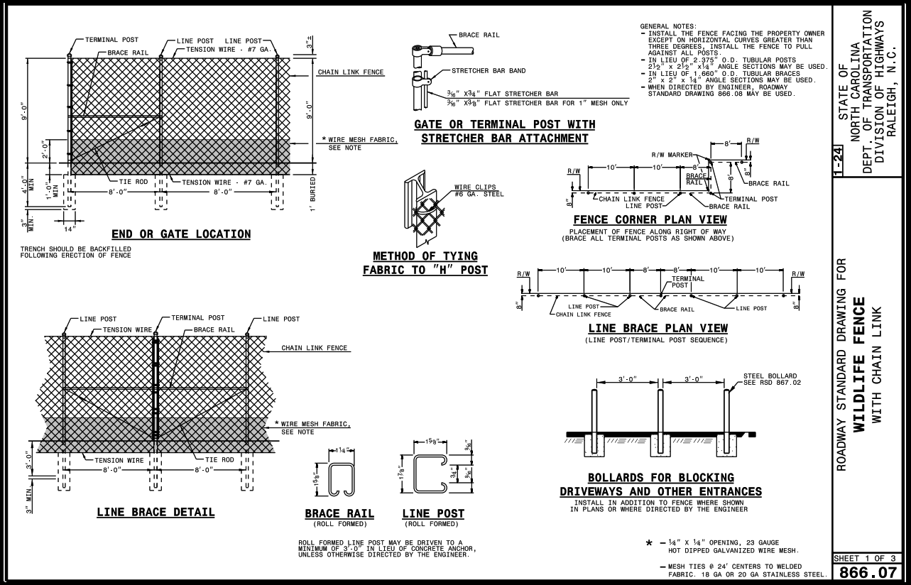
Figure 20. Wildlife fence standard detail (866.07).

There are many factors that must be considered with wildlife fencing such as terrain, private property, access points, ditch crossings, gates, maintenance, etc. Gaps and openings in fences create pathways for wildlife to access the roadside of the fencing therefore greatly reducing the effectiveness of the fence and risking wildlife vehicle collision. For maintenance purposes the fence should be placed inside the right-of-way limits. Slope considerations should evaluate both the positive and negative effects of the slope alignment. A higher terrain on the roadside of the fence (Figures 21 and 22) can effectively work as a jump out for larger species such as white-tailed deer. Conversely a high slope outside the fence increases the possibility of wildlife accessing the roadway.

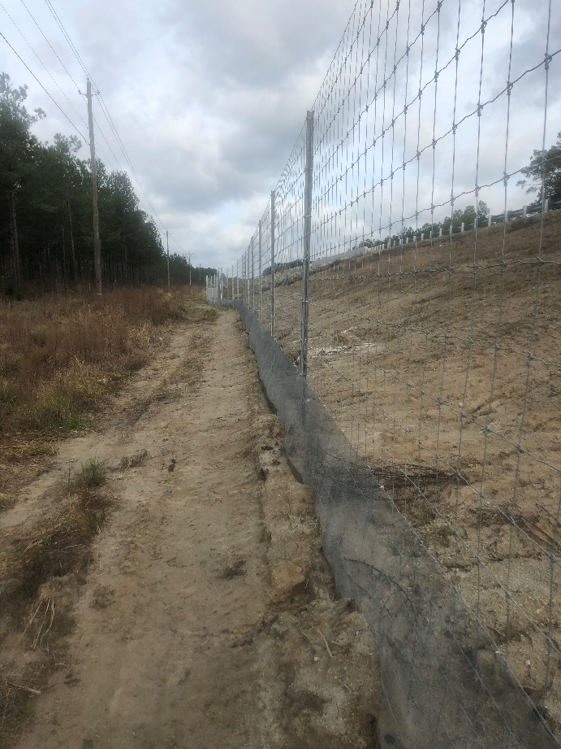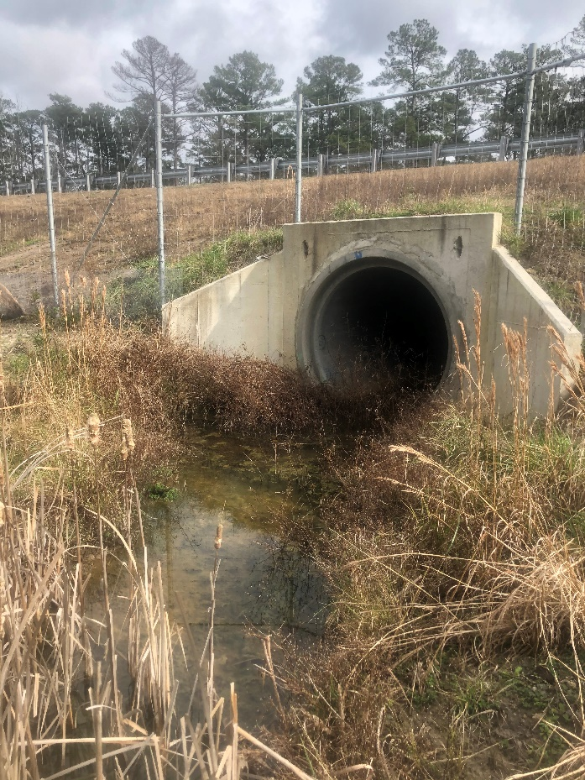
Figures 21 and 22. Wildlife fence run (left) and tie in to crossing structure (right). US 17 Jones County

Greenway and Trail Considerations
The combined presence of greenways or trails with wildlife passage is a common issue. The two are not mutually exclusive, however there are multiple factors that need to be considered in those circumstances.
Foremost is how the presence of people using the structure can shift the amount, timing and type of usage by wildlife. How significant that shift is will vary depending on the type of trail and trail activity. Example: A highly used urban greenway will have a more significant impact on wildlife usage than a rural portion of the Mountains to Sea trail. When looking at trail type in conjunction with the wildlife passage objective a busier more developed trail should provide physical separation from the wildlife corridor to the maximum extent practicable while also providing vegetated screening. This approach will help ensure the wildlife corridor will accommodate a broader range of wildlife species.
A designed wildlife bench or crossing may look very attractive in the future to use as part of a trail corridor. For this reason, it is important to document the original intent of the wildlife passage and consider the above factors when considering a trail addition.

Maintenance of Crossing structures
In most cases wildlife crossing measures will not include maintenance beyond what NCDOT typically incurs for a standard structure; however, there are a couple of significant exceptions that are paramount to supporting the investment made in the crossing. These include:
- Vegetation maintenance within a wildlife crossing should be coordinated with NCWRC prior to cutting or spraying. Uncoordinated clearing activities have resulted in crossings being blocked or filled by brush often covering existing wildlife trials. Vegetation management is necessary for both NCDOT right-of-way maintenance and the success of the wildlife crossing. Vegetation management activities are typically more frequent in the earlier years post construction until a suitable vegetation structure and setback are established.
- Wildlife fence maintenance will insure both the integrity and longevity of the fence. Vegetation can easily grow through and over a fence eventually stressing the fence. Right-of-way setbacks and routine vegetation management around the fence can reduce problems, increase the life of the fence, and allow easy visual inspection from the roadway. Gaps in the fence that develop from tree falls, vehicle crashes, etc. should be repaired immediately upon finding. Wildlife will quickly find new gaps in the fence and access the roadway significantly increasing the likelihood of a wildlife-vehicle collision.
- It is also important to coordinate with WRC on all projects adjacent to wildlife crossings to assure the activities will not impact the effectiveness of the structure. Even inconspicuous projects such as highway lighting, emergency management signs, utility work, access breaks, ect. could have adverse effects on wildlife use of a crossing structure. Wildlife crossing locations can be found at (Add link to Crossing layer)

Animal-Vehicle Collision Data
NCDOT and NCWRC are continually improving the collection of wildlife vehicle mortality data to help assess the need for warning signs, crossing structures, fencing, and other mitigative efforts (Figure 23). Reported animal vehicle collisions (AVC) data are available and may support mitigation measures for some projects. Reportable crashes are those that involve injury or meet the $1,000 property damage threshold. North Carolina had over 20,000 reportable animal AVCs including four fatalities in 2022, (NCDOT 2020-2022). The estimated comprehensive crash costs for all of North Carolina’s 2022 AVC is $486,000,000 (based on NC Standardized Crash Cost 2022). Carcass removal data has documented actual AVC occurrences more than five times greater (in Utah study) and nine times greater (in Virgina study) than the accident reported AVC numbers (Olson, 2013; Donaldson & Lafon, 2008). Applying the most conservative correction factor to reportable AVC suggests there are closer to 100,000 large AVC occurring annually in North Carolina.

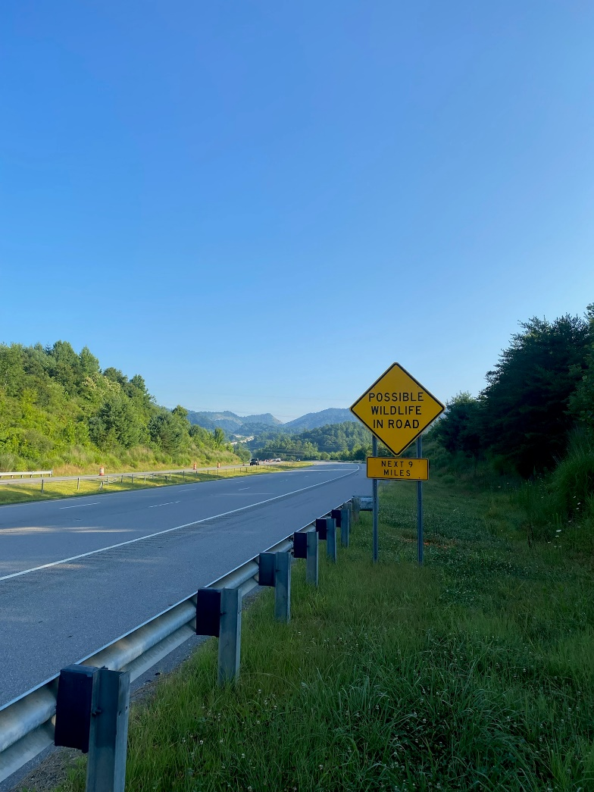
Figure 23. Wildlife warning on I-26 West, Madison County.

References
Bissonette, J.A., and Rosa, S. An Evaluation of a Mitigation Strategy for Deer-Vehicle Collisions. Wildlife Biology, Vol. 18, No. 4, 2012, pp. 414-423. An evaluation of a mitigation strategy for deer‐vehicle collisions - Bissonette - 2012 - Wildlife Biology - Wiley Online Library
Clevenger, Anthony P., et al. “Highway Mitigation Fencing Reduces Wildlife-Vehicle Collisions.” Wildlife Society Bulletin (1973-2006), vol. 29, no. 2, 2001, pp. 646–53. JSTOR, http://www.jstor.org/stable/3784191. Accessed 31 Oct. 2023.
Dodd, N., and Gagnon, J.W. Preacher Canyon Wildlife Fence and Crosswalk Enhancement Project, State Route 260, Arizona. Arizona Game and Fish Department, Research Branch, Phoenix, 2008. Dodd, N. L., J. W. Gagnon (yumpu.com)
Donaldson, B. M., & Lafon, N. W. (2010). Personal Digital Assistants to Collect Data on Animal Carcass Removal from Roadways. Transportation Research Record, 2147(1), 18-24. https://doi.org/10.3141/2147-03
Matthew F. McCollister and Frank T. van Manen "Effectiveness of Wildlife Underpasses and Fencing to Reduce Wildlife–Vehicle Collisions," Journal of Wildlife Management 74(8), 1722-1731, (1 November 2010). https://doi.org/10.2193/2009-535
NCDOT 2020-2022 2021 Animal Crash Data (ncdot.gov)
Olson, Daniel D., "Assessing Vehicle-Related Mortality of Mule Deer in Utah" (2013). All Graduate Theses and Dissertations, Spring 1920 to Summer 2023. 1994.
https://digitalcommons.usu.edu/etd/1994
2022 Standardized Crash Cost Estimates for North Carolina. Microsoft Word - Crash Costs 2022_20230602.docx (ncdot.gov)

